# Creaking Grounds

## Week 1 – September 24, 2015

### Overall:

This week we wanted to focus on creating the foundation of our game and truly understanding what our end goal was to be for this semester and possibly further if we wish to take that step. We began with a meeting during the weekend to play a board game that this game was inspired by. As a team we wanted to understand where the designer came from so we too could share his vision and build onto it. In addition, it was a good time to get to know one another and build the groundwork for a strong team. We spent time afterwards creating ideas and narrowing down what we thought would be a good game. With the team feeling inspired and motivated to build something great, we started working on building our 3D multiplayer game and artwork. We finished our tasks early and have moved onto the following week.

### Tasks and Time Commitment:

This week we focused on idea creation together as a team, then worked on a few game mechanics and artwork. Our meetings totaled to be about 4 hours this week.

|  |  |
| --- | --- |
| Andrew Eagle | * Begin creating basic ideas and user stories that we believe are the core of the game [Estimated: 6 hours | Actual: 6 hours] * Layout a mansion with specific rooms in the event, Room Randomization, is not possible in our time limit [Estimated: 1 hours | Actual: 1 hours] |
| Conner Garrison | * Build a 3D box test room which will consist of a floor, wall, and a light source in Unity. [Estimated: 1 hours | Actual: 0.5 hours] * Create a player which can look around in first person. This character must be able to jump, run, and sprint. [Estimated: 1 hours | Actual: 0.5 hours] * Create Wall Collisions so the player cannot leave the test room. [Estimated: 1 hours | Actual: 0.5 hours] |
| Sean Drevs | * Create the first piece of concept art. This artwork must depict what the users will feel upon starting the game. [Estimated: 6 hours | Actual: 8 hours] * Begin modeling of four 3D player models. 2 male, 2 female. To begin, they will be generic and expanded upon over time. [Not Complete Yet, 1 week left] * Ensure the 3D models have animations for running, jumping, and idling. [Not Complete Yet, 1 week left] |
| Jason Marquez | * Organize GitHub for use of the team. The repos must be easy to understand and able to quickly find what is needed by the team at any given time. [Estimated: 1 hours | Actual: 0.5 hours] * Establish and organize the Trello system. Which is the creation of two boards, Product Backlog and Sprint, a Contact Information board in the event members must be contacted, and cards inside with examples. Jason must ensure that the team understands the use of Trello. [Estimated: 1 hours | Actual: 0.5 hours] * Take notes on every meeting to make sure everything is well documented * Creation and submission of the Team’s report [Estimated: 1 hours | Actual: 1 hours] |

### Incomplete Tasks:

This week we did not have any incomplete tasks. We expected Sean to take some time to create the 3D models and animations so we have given him two weeks to complete the task. If anything we did not fully know the capabilities of each other and how long each task will take. We’ve now moved onto the next week and have completed some work that we wanted to get done by next Thursday.

Below is a task we’re already working on and have completed. We did not list these in the Tasks section because we did not set these as the tasks this week.

* Create a test furniture object with animation upon interaction [COMPLETE] [Estimated: 5 hours | Actual: 5 hours]
  + Object is an end table which will open the drawer when player looks at the object and presses ‘E’. The player can then close the drawer when pressing ‘E’ again.

### Burndown Chart:

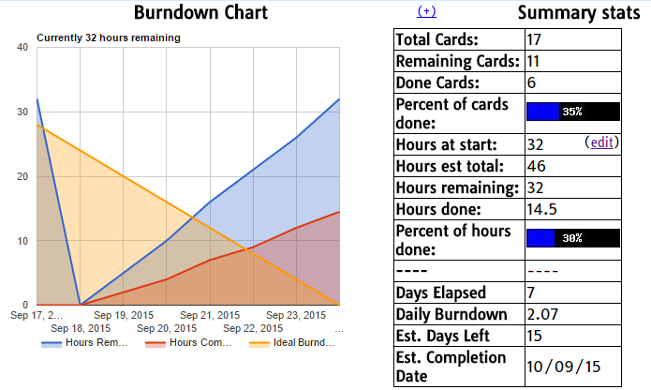

Burndown does not accurately display hours this week. We’ve added our new tasks due next week (10/1) already since we’re ahead.